# Machine Learning

Bojan Božić & Bujar Raufi

School of Computer Science

TU Dublin, Grangegorman

bojan.bozic@tudublin.ie; bujar.raufi@tudublin.ie

Lecture 1: Introduction

Bojan Božić & Bujar Raufi

School of Computer Science

TU Dublin, Grangegorman

bojan.bozic@tudublin.ie; bujar.raufi@tudublin.ie

**Slides adapted from Sarah Jane Delany and book slides from: Fundamentals of Machine Learning for Predictive Data Analytics. Kelleher, Mac Namee and D’Arcy**

## Week 1 - Intro

### Overview

* Administrivia
* Module Outline
* Machine Learning Today - the good, the bad and the ugly
* Machine Learning Introduction
* What is (supervised) ML?
* Supervised v Unsupervised Learning
* Representing Data as Features

### Lecture and Lab:

* Thursday: 6pm to 10pm
* Weeks 1, 7 and 13 will be in-person (but streamed), the rest will be online
* No lecture on week 13 (07.05.2026)!
* All notes, lecture recordings, tutorials, lab work, and assignments will be available on Brightspace.
* For all module queries please contact: [bojan.bozic@tudublin.ie](mailto:bojan.bozic@tudublin.ie)

#### Book

* *Fundamentals of Machine Learning for Predictive Data Analytics*: John D. Kelleher, Brian Mac Namee, Aoife D'Arcy



#### ML with Python

* Tutorials and lab work require a laptop with Jupyter and scikit-learnn
* Require >> Scikit-learn >> <https://scikit-learn.org/stable/>



#### Assessment

* Assessment is based on CA + final exam:

|  |  |
| --- | --- |
| **Percentage** | **Activity** |
| 30% | Assignment - due in week 13 |
| 20% | Lab Test - scheduled for week 9 |
| 50% | End of Semester Exam |

### Machine Learning - Overview

* Supervised Learning
  + Classification: KNNs, Decision Trees, Naive Bayes
    - Neural Networks
    - Linear regression, Logistic Regression
  + Dimensionality Reduction
    - Feature Selection, PCA
  + The ML Process
    - Data Preprocessing, Missing Values, Scaling
    - Model Selection, Hyperparameters
  + Evaluation
  + Working with Text
  + Unsupervised Learning

#### Relevance of ML

* Explosion in rich, complex data to analyse - online and offline.
* •Significant recent progress in algorithms and theory.
* •Computational power is now available.
* •Industry demand - Data scientists, Data engineers…
* •New applications in many disciplines - medicine, engineering, humanities…
* Instagram >>
  + **2.4 billion users** end of 2024
  + Average Daily Usage of Instagram is **33 Minutes**
* Gmail
  + **more than 1.8 billion** users worldwide.
  + Around 22.22% of the global population uses Gmail.
  + **121 billion** emails daily (as of 2022 data)

#### How ML fits in this program

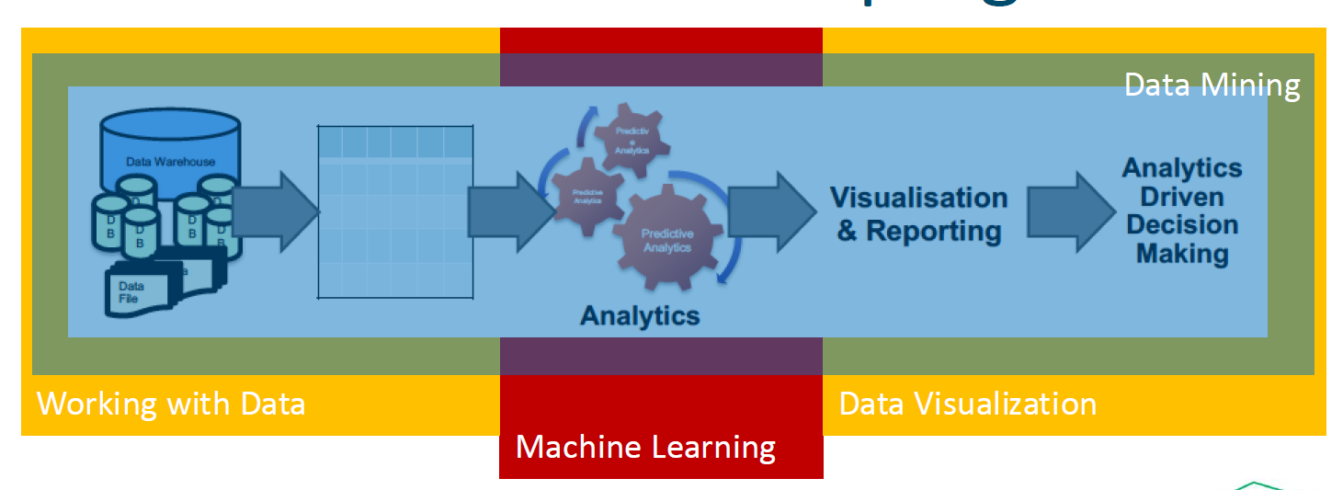

#### ML Today – Advances in AI

* Images - Dall-E: generating realistic images from a description in natural language <https://openai.com/dall-e-2/>



ChatGPT: A chatbot built on large language models that interacts in a conversational way <https://openai.com/blog/chatgpt/>

#### Reactions



<https://www.independent.ie/irish-news/politics/two-government-departments-confirm-use-of-chat-gpt/a1788591640.html>



<https://www.japantimes.co.jp/news/2023/01/24/asia-pacific/australian-colleges-chatgpt-disabled-students/>



<https://www.nytimes.com/2023/02/03/technology/chatgpt-openai-artificial-intelligence.html>



<https://www.thetimes.co.uk/article/irish-universities-in-race-against-time-with-chatgpt-to-avoid-widespread-cheating-scandals-kbpmtqqw9>

#### Education

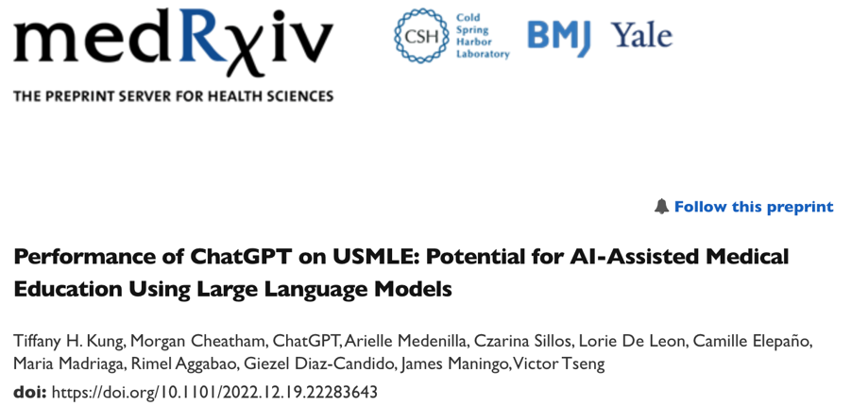

<https://www.medrxiv.org/content/10.1101/2022.12.19.22283643v2.full>



<https://www.cam.ac.uk/stories/ChatGPT-and-education>



<https://mackinstitute.wharton.upenn.edu/wp-content/uploads/2023/01/Christian-Terwiesch-Chat-GTP.pdf>

#### GPTZero to detect AI



<https://www.zerogpt.com/?gclid=CjwKCAiAkp6tBhB5EiwANTCx1AmcBLk3uO8ijqusyd1ngey8R2HZxG1WAwYgXoUuWFGDZ5xK7nVQlhoCad8QAvD_Bw>

#### But…

* ChatGPT can put together answers to questions but doesn’t “know” anything
* •No comprehensive understanding of the physical and social world, no ability to reason about relationships between concepts and entities
* •chatgpt failures guthub repo --- Examples of failures <https://github.com/giuven95/chatgpt-failures>

A year ago… 

This year…



#### DeepSeek

* Nvidia 2022 export ban
* •DS built at a fraction of the cost of industry-leading models like OpenAI - because it uses fewer advanced chips.
* •It is reportedly as powerful as OpenAI's o1 model - released at the end of last year - in tasks including mathematics and coding.
* •Like o1, R1 is a "reasoning" model. These models produce responses incrementally, simulating a process similar to how humans reason through problems or ideas. It uses less memory than its rivals, ultimately reducing the cost to perform tasks
* Source: <https://www.bbc.com/news/articles/c5yv5976z9po>



#### Next

* Applications will get more specific.
* •Regulation
* •EU AI Act
  + <https://artificialintelligenceact.eu/>

#### AI Systems are still brittle…



<https://www.theverge.com/tldr/2020/11/3/21547392/ai-camera-operator-football-bald-head-soccer-mistakes>

<https://medium.com/thoughts-and-reflections/racial-bias-and-gender-bias-examples-in-ai-systems-7211e4c166a1>



<https://www.theguardian.com/technology/2022/dec/22/tesla-crash-full-self-driving-mode-san-francisco>

### Expert Systems (Rule-Based Systems)

1. Rule:

**If**

– Income > Expenditure &

– Collateral > Loan

**Then**

– Risk = Low

Knowledge engineering



#### Learning from historical data



Predict decision for new instance

* Table of historical data
* Each row
  + description of instance
  + decision (Yes/No)

#### Learn What?

* + A.Learn expert decision-makingWhat if the expert gets it wrong sometimes?
  + B.Learn from outcomesOutperform experts



### Supervised learning

#### Supervised ML (Predictive Analytics)

* **Training Step:**
  + Learning a model from a set of historical data instances



#### Supervised ML (Predictive Analytics)

* **Prediction Step:**
  + Using the model to make predictions



#### Classification Task

* Example: Credit scoring
  + A training set with 10 examples (customers)
  + example has one of two class labels = {High-risk, Low-risk}

#### Classification task

* Manually classify customers into two categories (low-risk and high-risk) based on savings and income data.
* **If** 
  + income > ⍺ & savings > β
* **Then** 
  + Risk - low



#### Classification Task

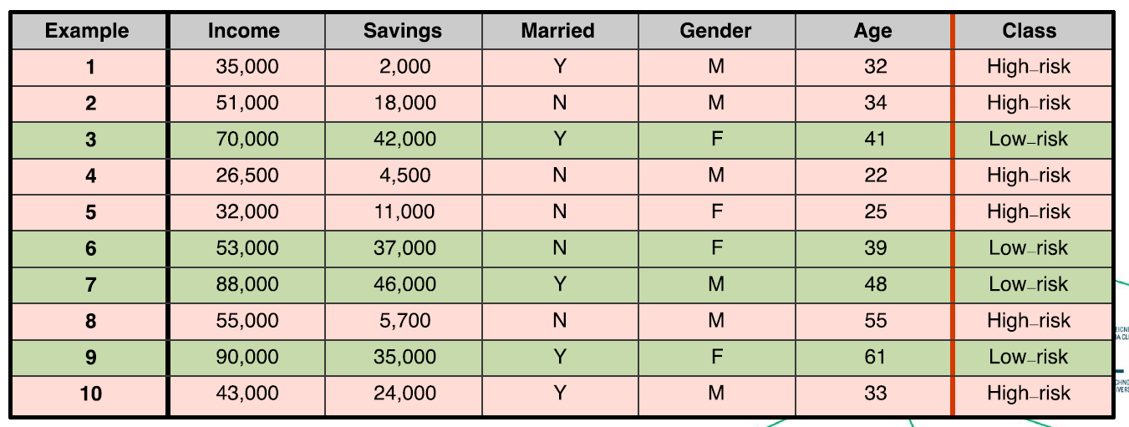

**Q. To which class does this new customer belong?**



**Q. Can we train an algorithm to learn to automatically classify new customers as either low-risk or high-risk?**

#### Supervised Learning

* Supervised Machine Learning algorithms automate the process of learning a model that captures the relationship between the **descriptive features** and the **target feature** in a **training dataset.**



* ML algorithms search through all possible patterns that exist between a set of descriptive features and a target feature to find the best model that is **consistent** with the training data (i.e. agrees with all the training instances).
* •Useful predictive models must be able to **generalise** well, i.e. make predictions for queries that are not present in the training data.

#### What can go wrong?

* **Underfitting** occurs when the prediction model is too simplistic to represent the underlying relationship between the descriptive and target features.
* •**Overfitting** occurs when the model is so complex that it fits the data too closely and becomes sensitive to noise (e.g. mislabelled feature values).



### Supervised Learning Algorithms

* Typically, training data does not have enough information to choose a single best model, so additional assumptions are needed to drive the model selection, known as the **inductive bias.**
* **Restrictive bias** constrains the set of models that will be considered (e.g. linear regression considers models that produce predictions based on a linear combination of descriptive features)
* **Preference bias** guides the algorithm to prefer certain models over others (e.g., the decision tree prefers shallower trees)
* Different algorithms have a different inductive bias,
* It is important to identify the machine algorithm that will fit the predictive task most appropriately.

#### Supervised ML (aka Predictive Analytics)



#### Supervised ML (aka Predictive Analytics)



### Supervised vs. Unsupervised Learning

* **Supervised Learning:**
  + An algorithm that learns a function from examples of its inputs and outputs. It uses manually labelled example data (i.e. a training set ) to predict the correct answer for new unseen query inputs
  + .e.**g. Classification, regression algorithms**
* **Unsupervised Learning:**
  + An algorithm that finds structure in data where no manually labelled examples are available as inputs - i.e. there is no training set. These algorithms are more focused on data exploration and knowledge discovery.
  + e.g. **Clustering, topic modelling algorithms**

#### Supervised Learning

* **Classification:**
  + Examples are represented by a set of features, which help decide the target class to which a new query input belongs (i.e. the output is a class label or target feature).
* **Regression:**
  + Examples are characterized by a set of features which help decide the value of a continuous output variable (i.e. the output is a number).



#### Classification Tasks

* **Binary classification:** Assign a new query input to one of two possible target class labels.



* **Multiclass classification:** Assign a new query input to one of M > 2 different target class labels.



#### Representing Data

* Commonly, we use a tabular structure to represent a dataset, often referred to as the **analytics base table (ABT)**.
* •Each row represents a different example and comprises a set of **descriptive features**.
* •For prediction, each row also has a **target class label** or **target feature** for classification and regression, respectively - i.e. the “correct answer".



#### Representing Data

* The descriptive features used to represent examples can be distinguished by the type and number of values they can take.
* **Binary:** Takes only two values - a boolean True/False decisione.g. married={True, False}, test_result={Pass, Fail}
* **Categorical (Nominal):** A feature that takes values from a finite set of values, with no intrinsic ordering to the valuese.g. blood_group={A,B,AB,O}, nationality={French, Irish, Italian}
* **Ordinal:** A categorical variable with a clear ordering of the variables.e.g. grade={A, B, C, D, E, F}, dosage={Low, Medium, High}
* **Interval:** Values that allow ordering and subtraction but do not allow other arithmetic operationse.g date, time
* **Continuous:** Numeric measurements, with or without a fixed range for the values.e.g. temperature, price, age, weight, height, latitude, longitude etc.

#### Typical Classification Task

* The training set with N=10 examples (customers). Each is described by D=5 features: 3 continuous, 2 categorical
* Each example has one of two class labels = {High-risk, Low-risk}



* Q. To which class does this new customer belong?



### Algorithms

* Many different learning algorithms exist for prediction (e.g. k -nearest neighbour, decision tree, neural network, support vector machine).
* •Due to processing, memory, and storage constraints, problem dimensions will often determine which algorithm will be practically applicable.
* 1.Number of input examples N.
  + Sometimes millions of input examples.
* 2.Number of features (dimensions) D representing each input example.
  + Often 10-1000, but sometimes far higher.
* 3.For classification, the number of target classes M.
  + Often small (binary), but sometimes far higher.

### Machine Learning - Overview

* Supervised Learning
* •Classification: KNNs, Decision Trees, Naive Bayes
  + Neural Networks
  + Linear regression, Logistic Regression
* •Dimensionality Reduction
  + Feature Selection, PCA
* •The ML Process
  + Data Preprocessing, Missing Values, Scaling
  + Model Selection, Hyperparameters
* •Evaluation
* •Working with Text
* •Unsupervised Learning

### Questions ?

### Lab solution - LAB1_Preprocessing_Sols _updated.ipynb

‘’’ py

## Lab Exercise Week #1: Mastering Data Preprocessing in Machine Learning

### Objective:

The goal of this lab exercise is to delve into advanced data preprocessing techniques used in machine learning. Preprocessing is an important step in Machine Learning, otherwise you end-up with "garbage-in garbage-out" paradigm, meaning you feed the machine learning algorithm with bad data, you can expect bad performance. You will work with real-world datasets, handling missing data, encoding categorical variables, scaling features, and more.

### Dataset:

For this exercise, we will use the "<a href="https://archive.ics.uci.edu/ml/machine-learning-databases/adult/adult.data">Adult Income</a>" dataset from the UCI Machine Learning Repository. This dataset contains various features related to individuals and aims to predict whether a person earns more than $50,000 per year.

### Tasks:

#### 1). Data Loading and Initial Exploration:

<ul>

<li>Load the "Adult Income" dataset. Loading can be done by accessing it locally, after you have download it, or direct access via URL provided above.</li>

<li>Explore the dataset to understand its structure and features. Check the feature structure from the <a href="https://archive.ics.uci.edu/dataset/2/adult">UCI Repository</a>.</li>

<li>Identify the target variable and its distribution.</li>

</ul>

# Import necessary libraries

import numpy as np

import pandas as pd

from imblearn.over_sampling import RandomOverSampler

from sklearn.model_selection import train_test_split

from sklearn.impute import SimpleImputer

from sklearn.preprocessing import StandardScaler, OneHotEncoder

from sklearn.compose import ColumnTransformer

from sklearn.pipeline import Pipeline

from sklearn.ensemble import RandomForestClassifier

from sklearn.metrics import accuracy_score, classification_report

# Task 1: Data Loading and Initial Exploration

url = "https://archive.ics.uci.edu/ml/machine-learning-databases/adult/adult.data"

column_names = ['age', 'workclass', 'fnlwgt', 'education', 'education-num', 'marital-status', 'occupation', 'relationship',

'race', 'sex', 'capital-gain', 'capital-loss', 'hours-per-week', 'native-country', 'income']

data = pd.read_csv(url, names=column_names, sep=',\s', na_values=["?"])

# Explore the dataset

print("Dataset Info:\n", data.info())

print("\nTarget Variable Distribution:\n", data['income'].value_counts())

data

#### 2). Handling Missing Data:

<ul>

<li>Identify missing values in the dataset.</li>

<li>Implement a strategy to handle missing data (e.g., imputation or removal). Impute missing values with the median for numerical columns and the most frequent value for categorical columns.</li>

<li>Justify the chosen strategy.</li>

</ul>

# Task 2: Handling Missing Data

# Impute missing values with the median for numerical columns and the most frequent value for categorical columns

numerical_features = data.select_dtypes(include=['int64', 'float64']).columns

categorical_features = data.select_dtypes(include=['object']).columns

# exclude the income column as it will be the output column -it will be the target variable

categorical_features = categorical_features[~categorical_features.isin(['income'])] # exclude the income column as it will be the output column

numerical_transformer = SimpleImputer(strategy='median')

categorical_transformer = SimpleImputer(strategy='most_frequent')

preprocessor = ColumnTransformer(

transformers=[

('num', numerical_transformer, numerical_features),

('cat', categorical_transformer, categorical_features)

])

numerical_features

categorical_features

#### 3). Encoding Categorical Variables:

<ul>

<li>Identify categorical variables in the dataset.</li>

<li>Apply appropriate encoding techniques (e.g., one-hot encoding or label encoding). Use one-hot encoding for categorical variables.</li>

<li>Discuss the impact of encoding choices on model performance.</li>

</ul>

# Task 3: Encoding Categorical Variables

# Use one-hot encoding for categorical variables

preprocessor = ColumnTransformer(

transformers=[

('num', numerical_transformer, numerical_features),

# find cat no in the data ignore it...apply onehotencoding...

# convert categorical to binary numercial features

('cat', OneHotEncoder(handle_unknown='ignore'), categorical_features)

])

#### 4). Feature Scaling:

<ul>

<li>Identify features that require scaling.</li>

<li>Apply feature scaling using techniques such as Min-Max scaling or Standardization.</li>

<li>Discuss the importance of feature scaling in different machine learning algorithms.</li>

</ul>

# Task 4: Feature Scaling

# Apply Standardization to numerical features

preprocessor = ColumnTransformer(

transformers=[

# make sure all numbers are between 0 and 1

# i.e. age - between 10 and 18 and ayment = between 10K and 15K .. => payment dominates the model as bigger numbers

# so standardise so each feature contributes equally

# preserves shape + keeps negative values....

# Need to scale for >>> LinReg / LogReg / SVM / k-NN / PCA / NN

# do not need to scale for >> DT / RF / GradBoost (XGBoost, LightGBN)

#### NEVER FIT SCALAR on TEST DATA?? >>> fit on trainnig set..... transform train and tes using same scalar...otherwise data leakage

# DStandardScalar + MinMaxScalar + RobustScalar

('num', StandardScaler(), numerical_features),

('cat', OneHotEncoder(handle_unknown='ignore'), categorical_features)

])

#### 5). Feature Engineering:

<ul>

<li>Create new meaningful features based on existing ones.</li>

<li>Discuss how feature engineering can enhance model performance.</li>

</ul>

# Task 5: Feature Engineering

# Create a new feature "capital-diff" as the difference between capital-gain and capital-loss

data['capital-diff'] = data['capital-gain'] - data['capital-loss']

#### 6). Outlier Detection and Handling:

<ul>

<li>Identify potential outliers in numerical features.</li>

<li>Implement a strategy to handle outliers (e.g., removal or transformation).</li>

<li>Discuss the impact of outliers on model training.</li>

</ul>

# Task 6: Outlier Detection and Handling

# Identify and handle outliers using a suitable method (e.g., Z-score or IQR)

#### 7). Normalization and Transformation:

<ul>

<li>Apply normalization to achieve a normal distribution in numerical features.</li>

<li>Discuss the benefits of normalization in specific machine learning algorithms.</li>

</ul>

# Task 7: Normalization and Transformation (You can use standard scalar, minmax scalar or robust scalar)

# Apply normalization to achieve a normal distribution in numerical features

#### 8). Data Splitting:

<ul>

<li>Split the dataset into training and testing sets.</li>

<li>Justify the chosen ratio and the importance of a proper train-test split.</li>

</ul>

# Task 8: Data Splitting

X = data.drop('income',axis=1)

y = data['income']

print("input columns", X.columns)

print("output columns", y.name)

# split data as 80% for training and 20% for testing

# randome ensure reproduces the same each time

X_train, X_test, y_train, y_test = train_test_split(X, y, test_size=0.2, random_state=42)

print("shapes of training and testing")

print('X_train shape:', X_train.shape)

# output for yoru model, will be included in the training

print('y_train shape:', y_train.shape)

# test data for features

print('X_test shape:', X_test.shape)

# is the output in the mdoel used to check the accuracy fo the classifier

print('y_test shape:', y_test.shape)

X_train.columns

y

#### 9). Handling Imbalanced Data:

<ul>

<li>Identify if the target variable has an imbalanced distribution.</li>

<li>Implement techniques to handle imbalanced data (e.g., oversampling or undersampling).</li>

<li>Discuss the challenges posed by imbalanced datasets.</li>

</ul>

#Identify if the target variable has an imbalanced distribution.

# check the ytrain distribution - cna see what values you have fo ech class...has two classes

# cna see theres an imbalance

print("Class distribution before oversampling:")

print( y_train.value_counts())

# add mor samples for class that has lower number of samples

oversampler = RandomOverSampler(random_state=42)

# Apply the oversampling technique to the training set

# once applied datag will bebalanced for the training

X_train_resampled, y_train_resampled = oversampler.fit_resample(X_train, y_train)

print("Class distribution after oversampling:")

# can see no imbalance now...

print( y_train_resampled.value_counts())

#### 10). Pipeline Implementation:

<ul>

<li>Construct a preprocessing pipeline that includes all the steps above.</li>

<li>Discuss the advantages of using a pipeline in the context of reproducibility and efficiency.</li>

</ul>

# Task 10: Pipeline Implementation

# Construct a preprocessing pipeline with a classifier

pipeline = Pipeline(steps=[

('preprocessor', preprocessor),

# choose RF classifier

('classifier', RandomForestClassifier(random_state=42))

])

# Fit the pipeline on training data

# train the pipeline -- means all the traing data will ebpassed thru pre-processing steps first then thru classifier...

pipeline.fit(X_train_resampled, y_train_resampled)

# Make predictions on test data

# thsi tests yuor model...

# y_pred is the var for the predicted values...

y_pred = pipeline.predict(X_test)

# Evaluate the model

print("Accuracy:", accuracy_score(y_test, y_pred))

print("Classification Report:\n", classification_report(y_test, y_pred))

‘’’

## Week 2 – Similarity-based Learning (kNN) -n K means clustering

**Module Outline**

### Lab - LAB2_kNN.ipynb

Lab link >> <https://scikit-learn.org/stable/auto_examples/neighbors/plot_classification.html#sphx-glr-auto-examples-neighbors-plot-classification-py>

## Week 3 – Decisions Trees – 19th Feb 2026

* Moving into information based territory
* Bery popular and very well known
* Bery intuitive and used in a lto of things aswell…

### Lab solution

#### Main objective

* K-nearest-neighbour solution
* Objective

1. Understand the knn algorithm
2. Implement from scratch
3. Use build in functionality
4. Tune hyper parameters to optimise the model performance
5. Evaluate the model perforamane

1st step –

Load

### Guess Who game

## Week 4 – Naïve Bayes – 27th Feb 2026

## Completed

* Week 1
  + Content into this doc from pdf/ppt – yes completed
  + Lab completed – yes completed
  + Lab video watched back – yes completed – up to 30 mins….
  + Content Video watched back and notes added to this doc – no . sart @ 30 mins
  + Notes done in copy book? – no
* Week 2
* Week 3
* Week 4